1)Install git.

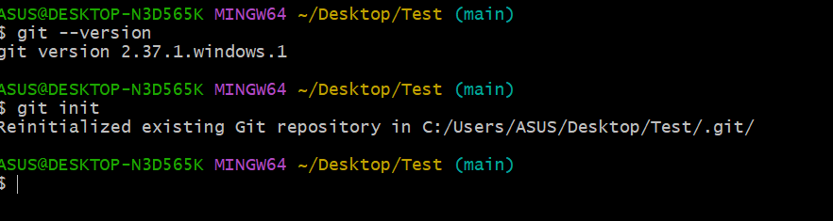

2)Create a repo in github with README.md and .ignore file.

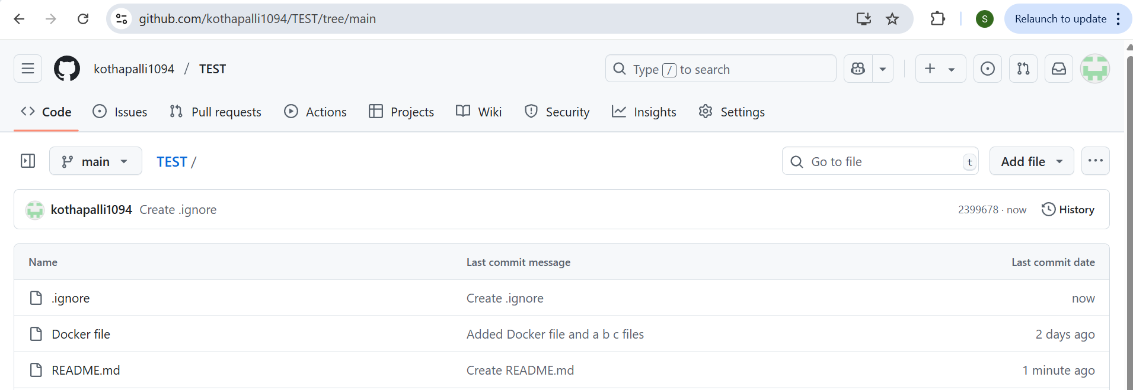

3)Clone the created repo to local.

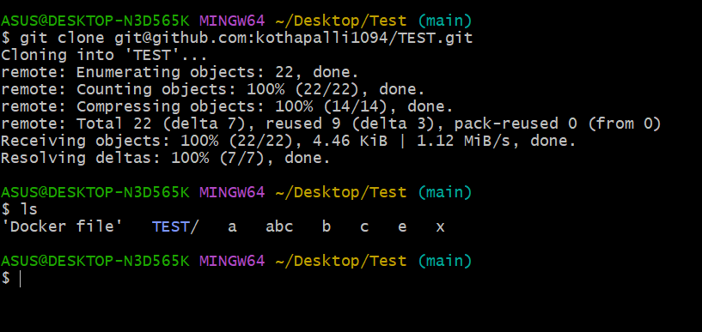

4)Create two files in local repo.

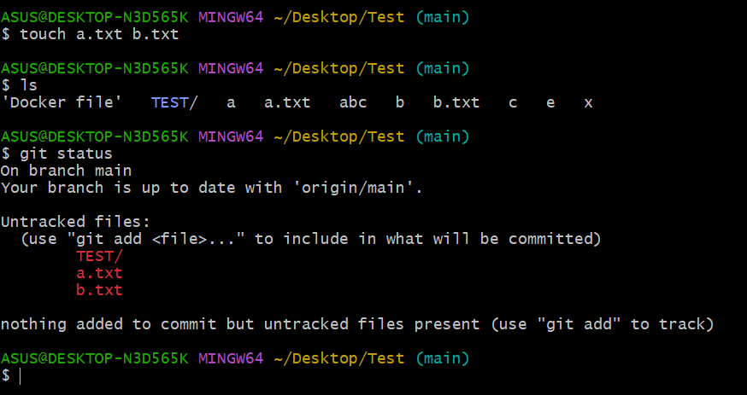

5)Commit two files and push to central Repository.

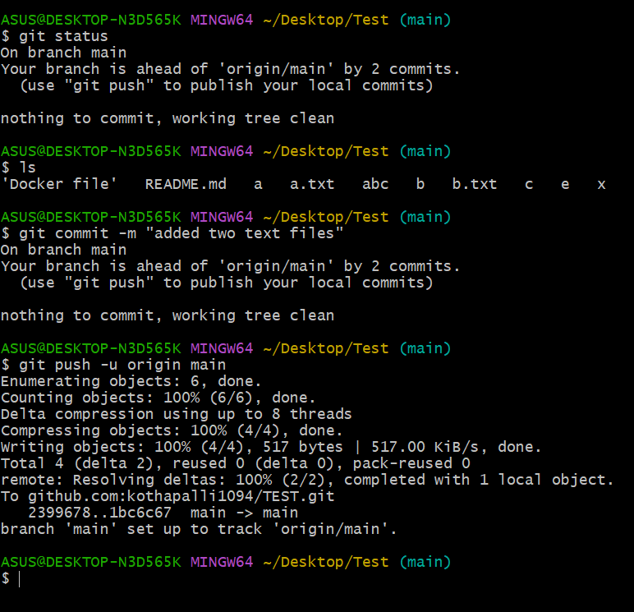

6)Create a branch in local and create a sample file and push to central.

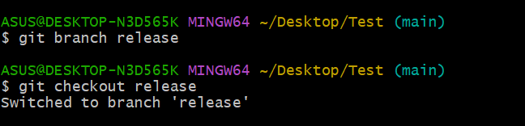

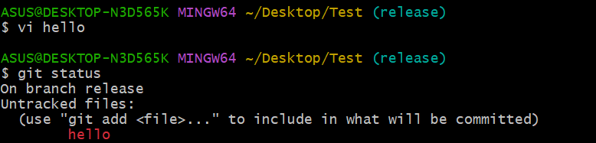

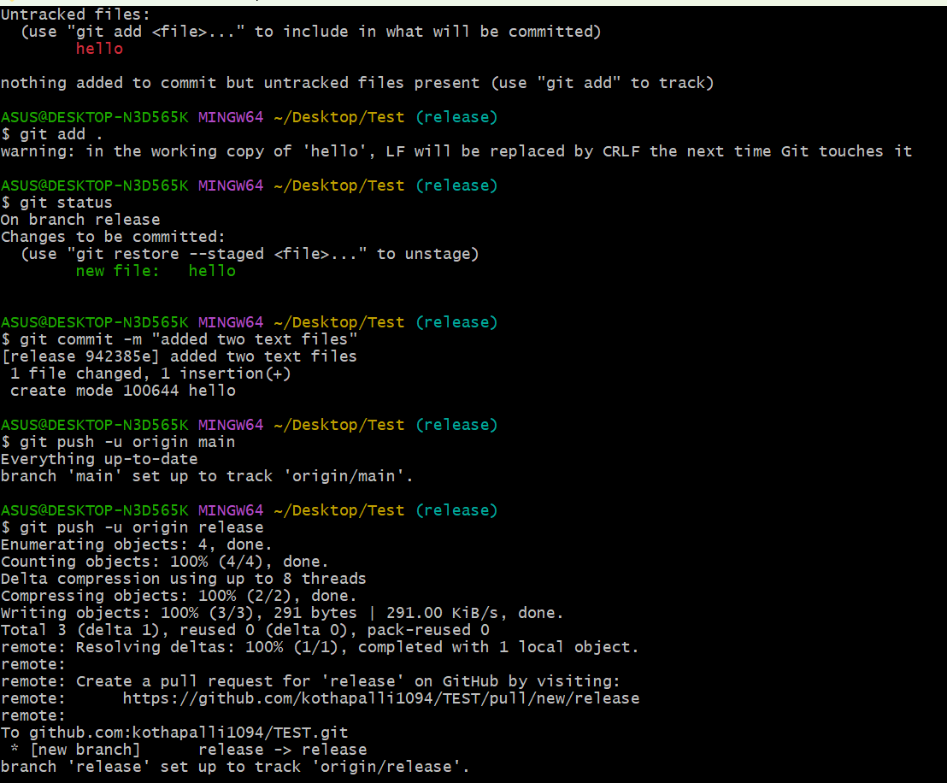

7)Create a branch in github and clone that to local.

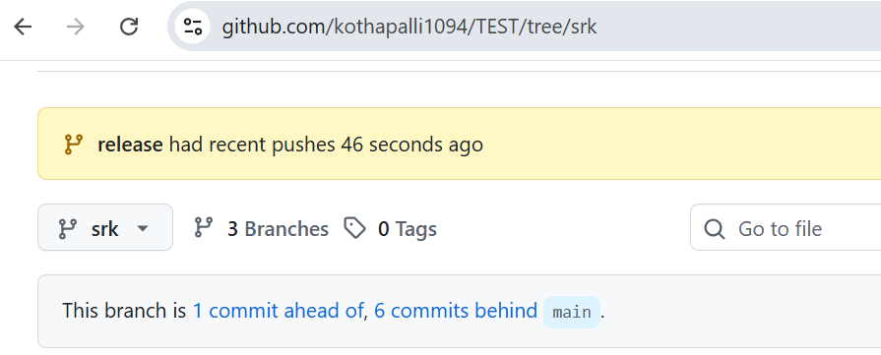

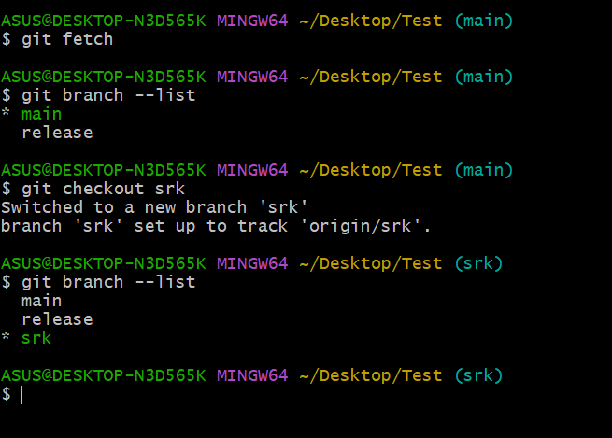

8)Merge the created branch with master in git local.

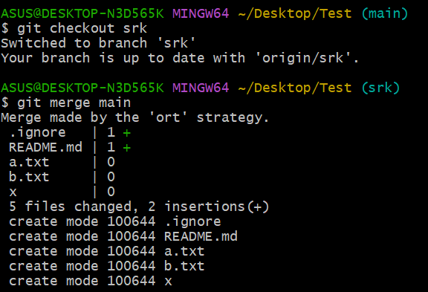

9)Merge the created branch with master in github by sending a pull request.

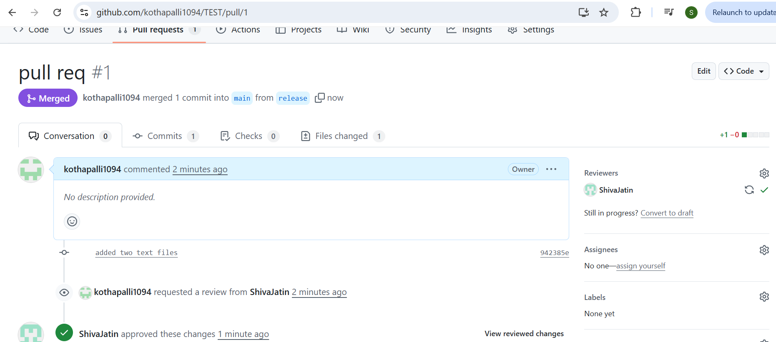

10)create a file in local and send that to branch in github.

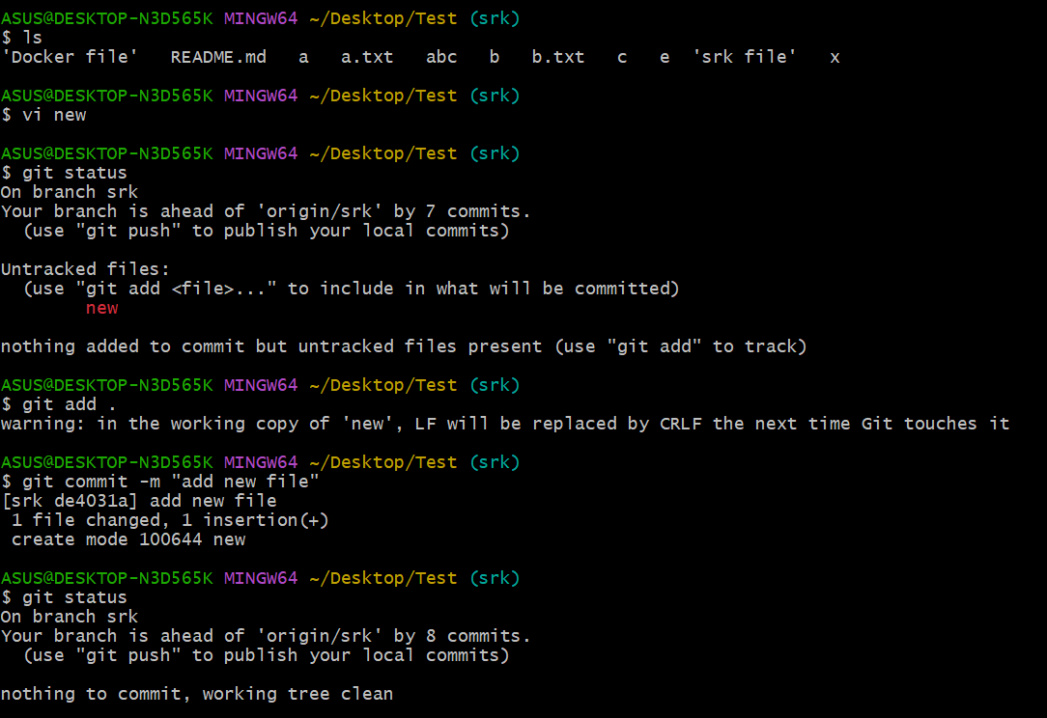

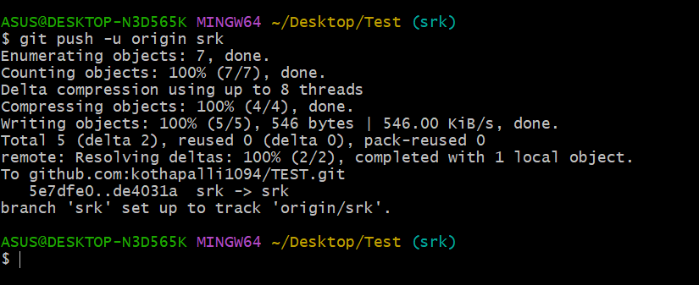

11)clone only a branch from github to local.

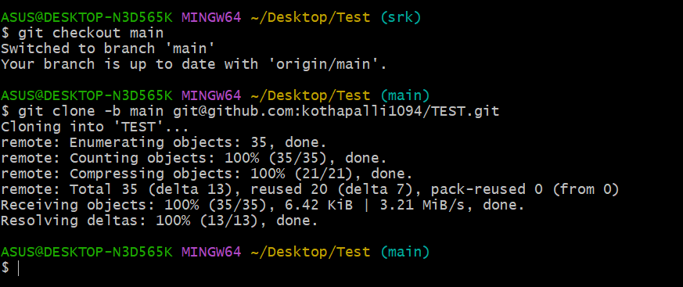

12)create a file with all passwords and make that untrackable with git.

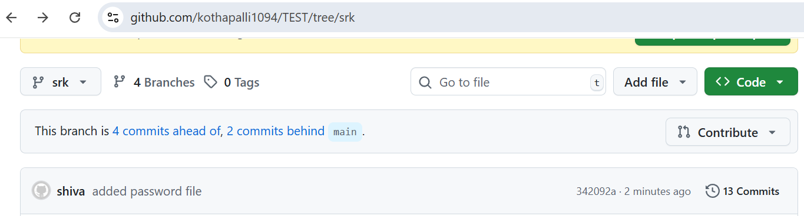

13)make a commit and make that commit reset without savings changes.

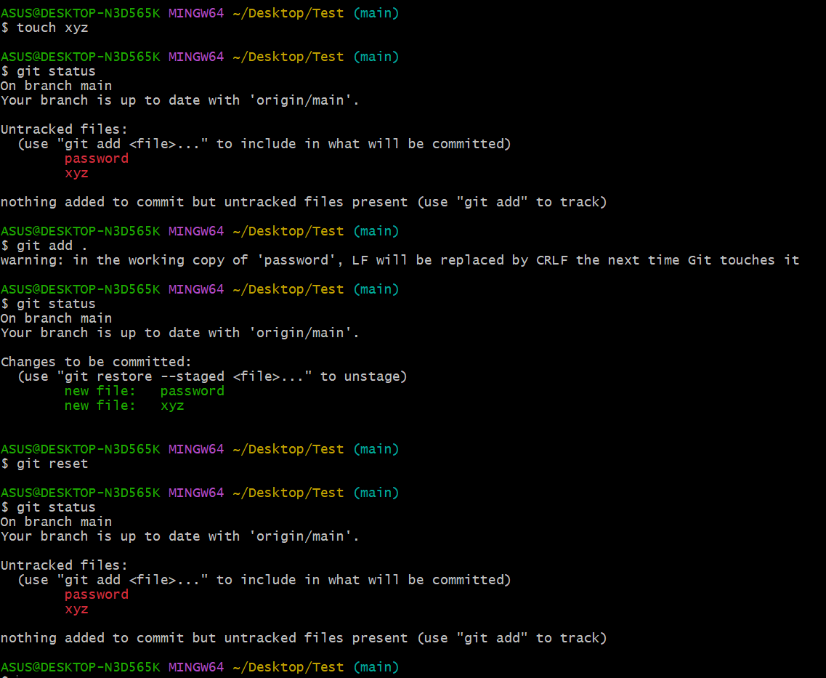

14)Revert a commited commit to the older version.

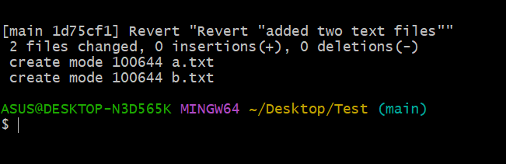

15)push a file to stash without savings the changes and work on another file.

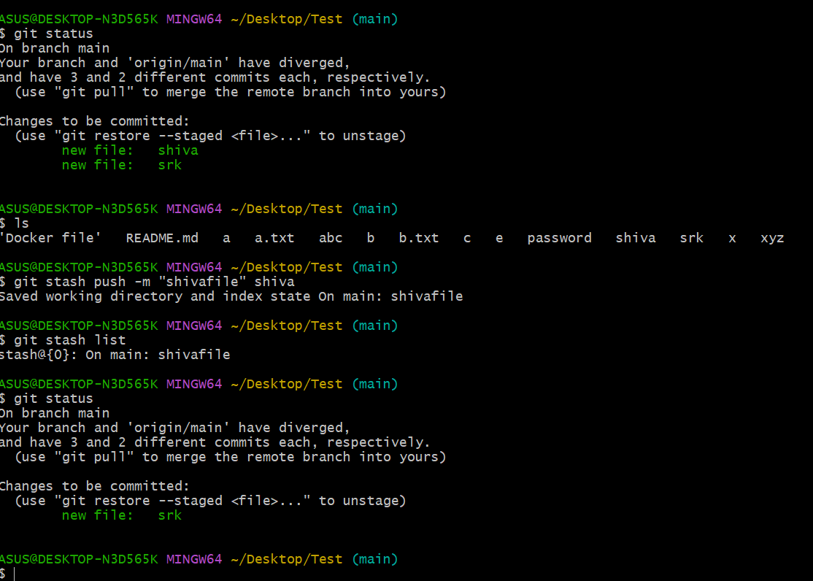

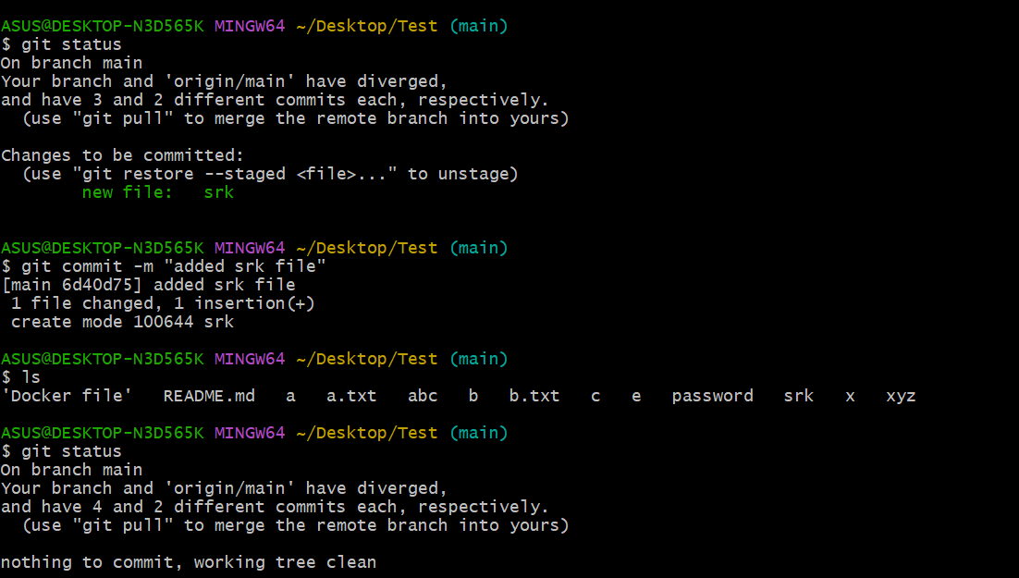

16)undo the stash file and start working on that again.

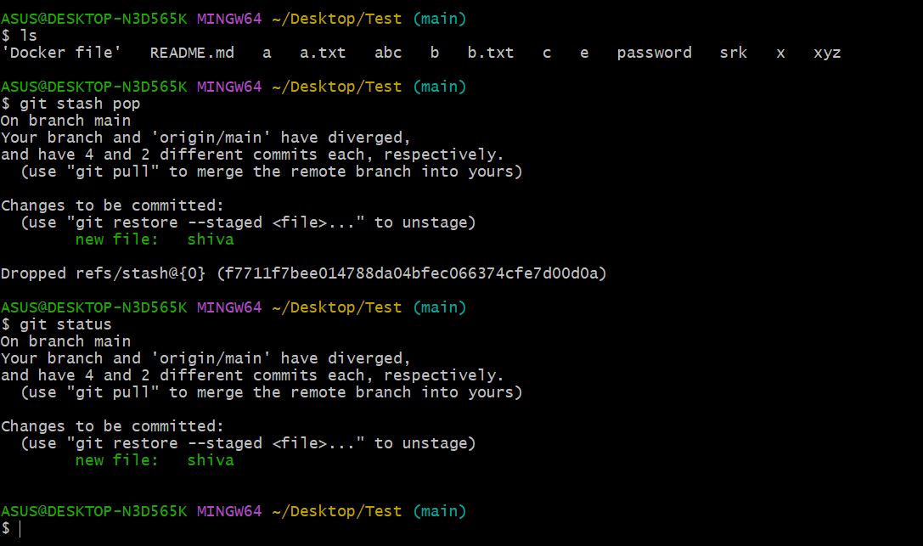

17)generate a ssh-keygen and configure into github.

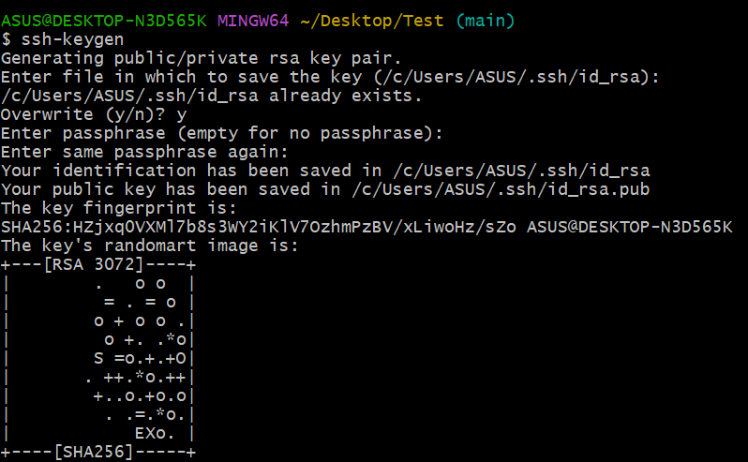

18)configure webhooks to github.

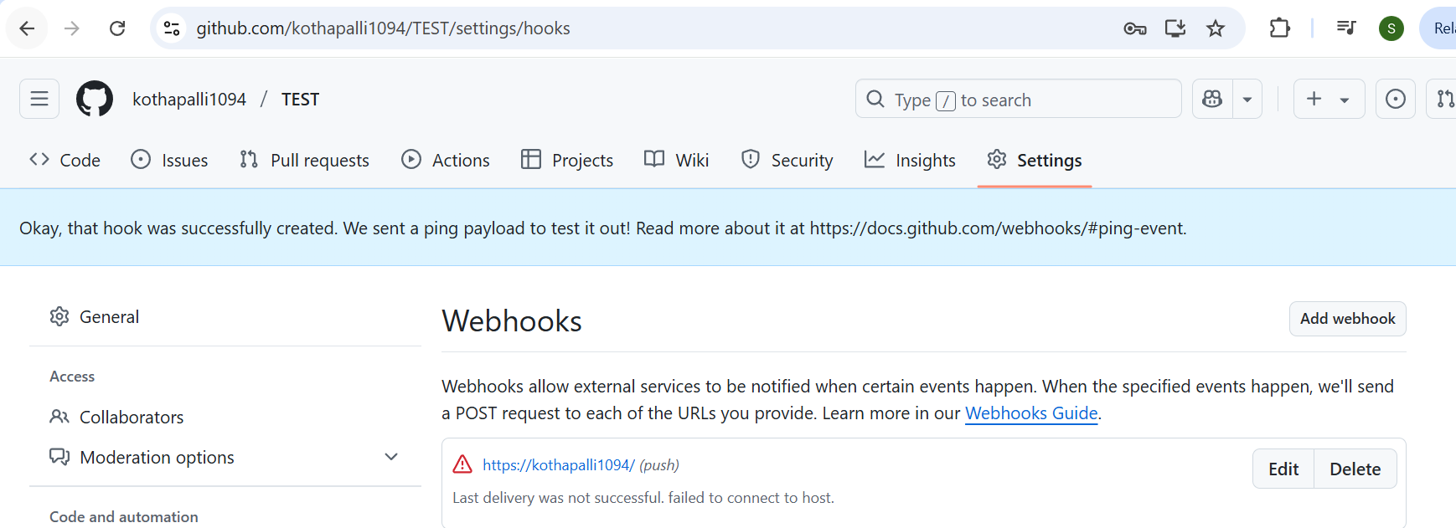

19)basic understanding of .git file.

.It stores all the information.

. Git needs to track changes, branches, commits, and more.

.When you run git init in a folder, Git creates the .git directory inside that folder.

20)Check all the logs of git.

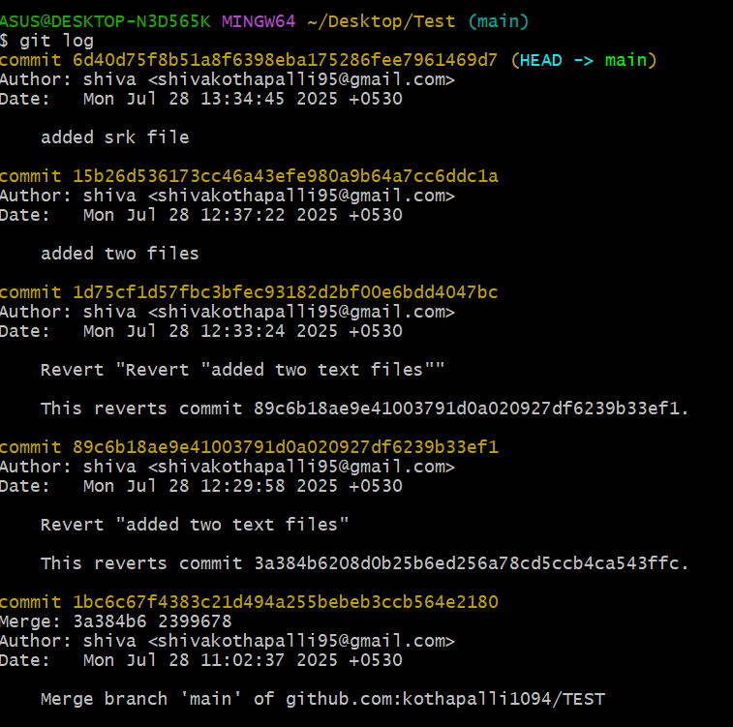

21)Rename the commit message.

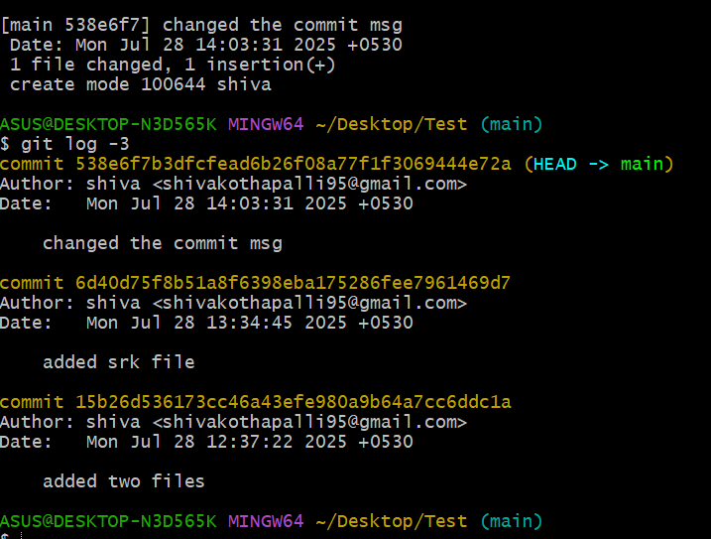

22)Merge multiple commits into single commit.

